Pg. 161 , Java Programming *A comprehensive Introduction*

Arrays Cont..

**Due Monday 4/7/14 during lab**

**Section 1: Define / Answer:**

import java.util.Arrays : returns a fixed-size list backed by the specified array

two-dimensional array- A two-dimensional array is an array where its elements are selected (identified) using two indices.

**Array Methods:**

**Find any 2 methods online of operating on an array and create a coded example.(Different from the ones below)**

Arrays.sort(*array-name*);

String *newarrayname* = Arrays.toString(*originalarrayname);*

Int [][] table = new int [3][4]

|  |  |  |  |  |
| --- | --- | --- | --- | --- |
|  | **0** | **1** | **2** | **3** |
| **0** | 0 | 0 | 0 | 0 |
| **1** | 0 | 1 | 2 | 3 |
| **2** | 0 | 2 | 4 | 6 |

1st method:

int[][] ary = new int[3][4];

int i, j;

for(i = 0; i < 3; i++) {

for(j = 0; j < 4; j++) {

ary[i][j] = I * (j + 1);

}

}

2nd method:

aryNumbers[0][0] = 10;

aryNumbers[0][1] = 12;

aryNumbers[0][2] = 43;

aryNumbers[0][3] = 11;

aryNumbers[0][4] = 22;

**Programming Assignment**

Task 1- Weather tracking array.

Create a program that allows the user to input 10 values into a one-dimensional array.

The values should represent 10 different temperatures.

The temperatures can be of any value.

Use a **for** loop to control the Scanner(System.in); inputs. There should be 10.

Use a different **for** loop to print a Sorted list of numbers in the Array from lowest to highest.

Create a **for** loop method to print the lowest value in the array and the highest value in the array. (Example: page 159)

Attach Snipping photos of your source code , the Scanner(System.in); inputs., and the sorted results.

For Example:

Enter a Temperature

5

Enter a Temperature

-6

Enter a Temperature

3

The temperature during the week was -6

The temperature during the week was 3

The temperature during the week was 5

The temperature was -6 degrees

The warmest temperature was 5 degrees.

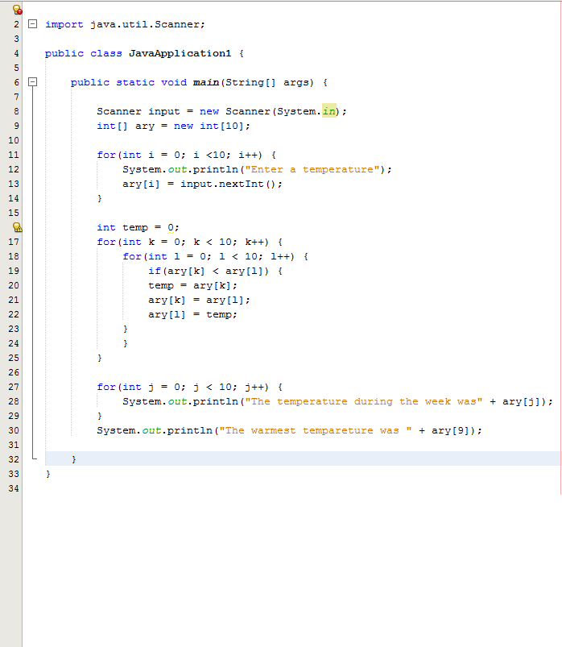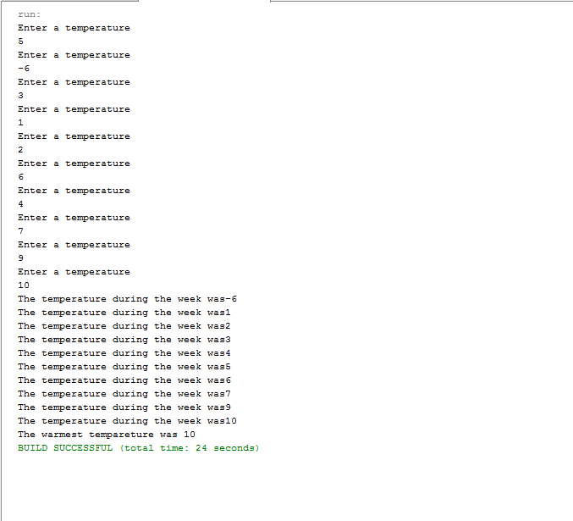

Task 2:

Create a two-dimensional array.

Type [] array-name = new type[5] [6]

Use a set of nested **for** loops filling a two-dimensional array to print the table below. Do not worry about printing the green numbers, they represent place holders.

(Figure out the correct equation to complete the table)

Attach Snipping photos with Source Code and Output.

***Hint: Exactly like figure 5-1 on page 162 of the book the numbers should be in numerical order. The numbers should be ascending from left to right and from top to bottom.

|  |  |  |  |  |  |  |
| --- | --- | --- | --- | --- | --- | --- |
|  | **0** | **1** | **2** | **3** | **4** | **5** |
| **0** | 1 | 2 | 3 | 4 | 5 | 6 |
| **1** | 7 | 8 | 9 | 10 | 11 | 12 |
| **2** | 13 | 14 | 15 | 16 | 17 | 18 |
| **3** | 19 | 20 | 21 | 22 | 23 | 24 |
| **4** | 25 | 26 | 27 | 28 | 29 | 30 |

